We recommend watching the installation video before attempting to install
Holden Colorado 2012-2020
Load-Lid Central Locking Fitting Instructions

Thank you for purchasing a quality Utemaster™ product, our aim is providing you with as much assistance as possible throughout the fitting process. Please contact us if assistance is needed.

Enter this address into your web browser to view the fitting video:
https://wi.st/2HJ58qs

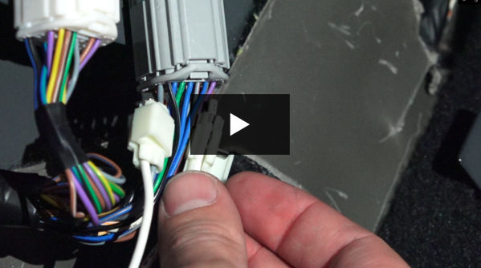

DESPATCH:

1x 80606-17 / WHUTELL-COL 1.1
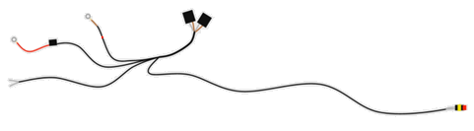

Step 1) Connect the relays

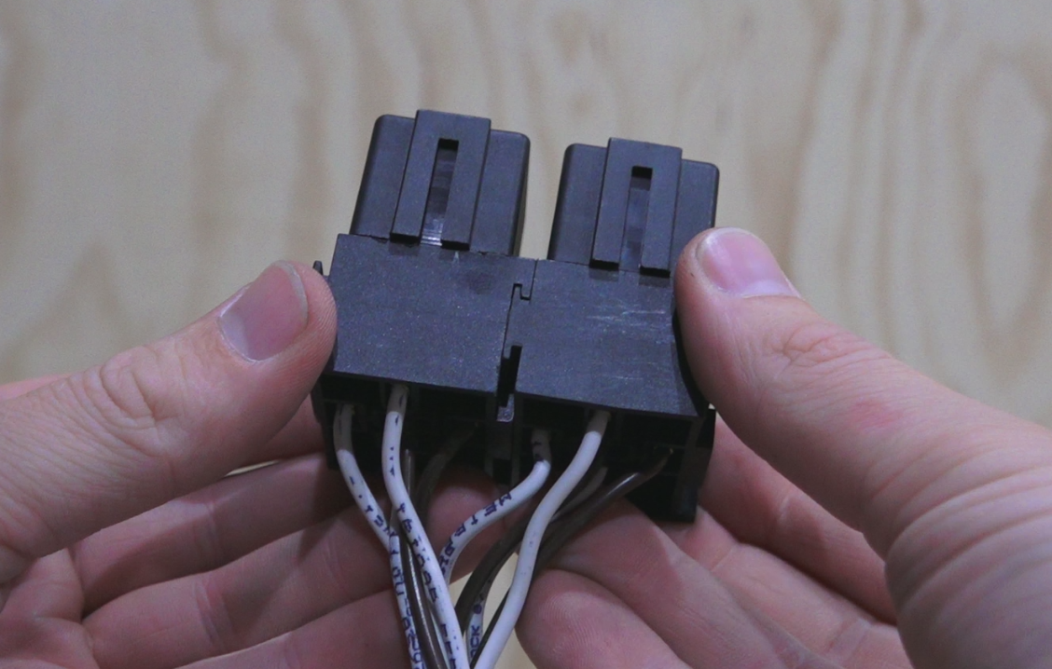

Step 2) Cable tie the relays in place

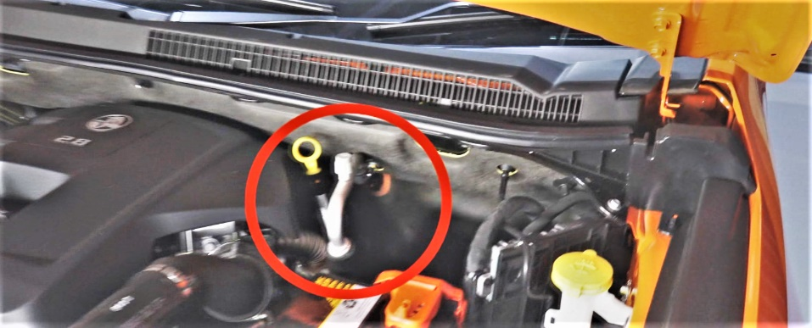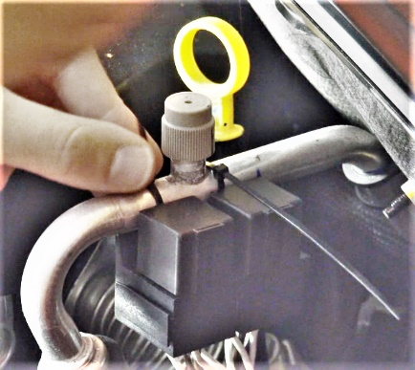

Step 3) Remove the earth bolt

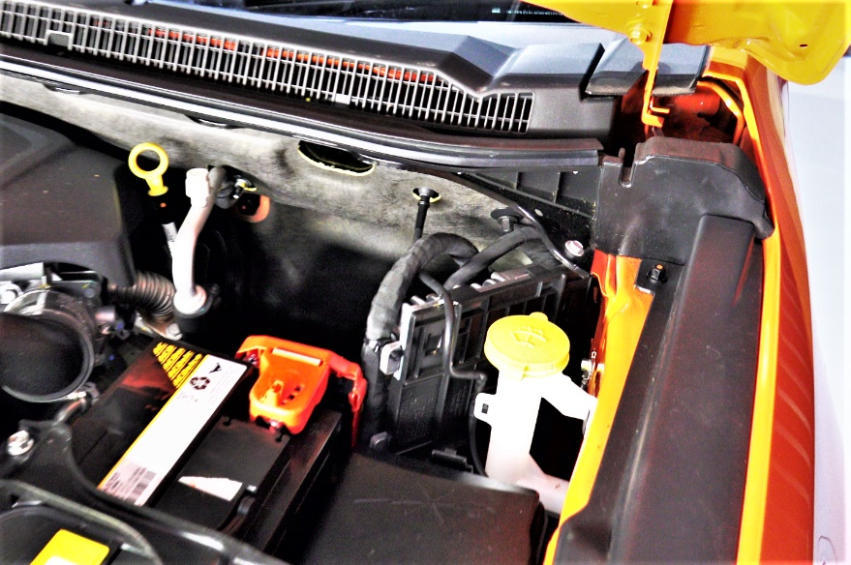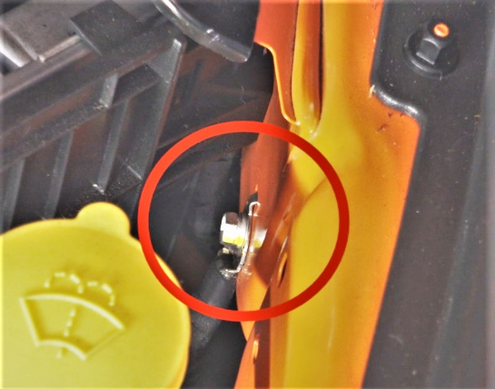

Step 4) Connect the earth cable to the earth point and re-install the bolt

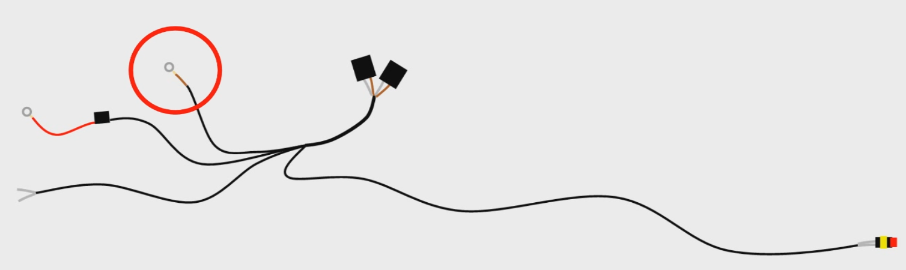

Step 5) Open the battery cover and remove the nut shown

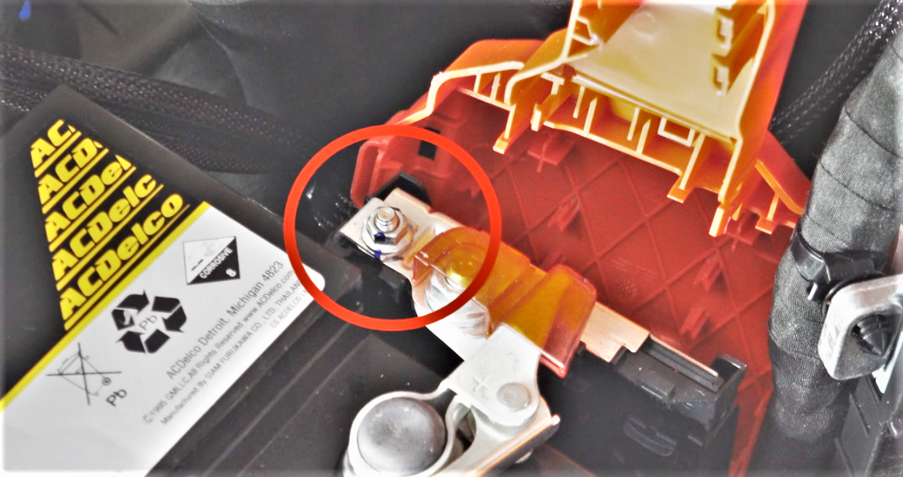

Step 6) Attach the power cable to the thread and re-install the nut. Close the battery cover

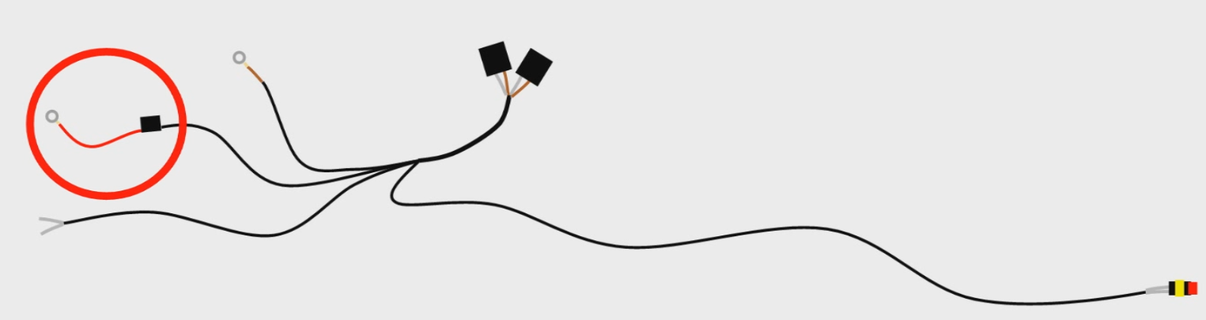

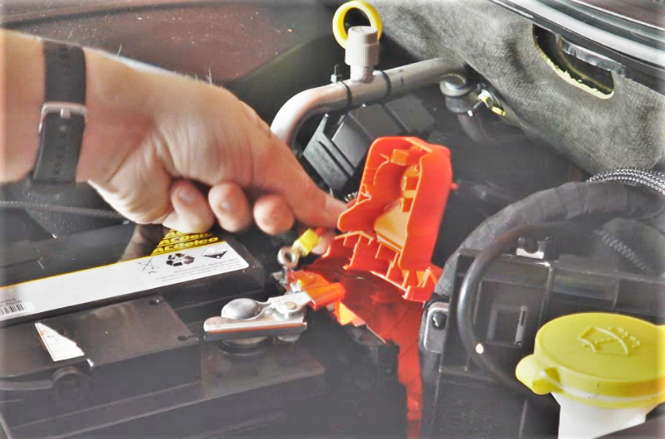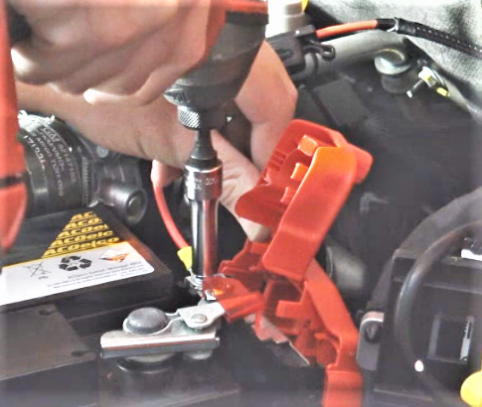

Step 7) Remove the plastic caps and rubber seal to expose the wiring behind the kick panel

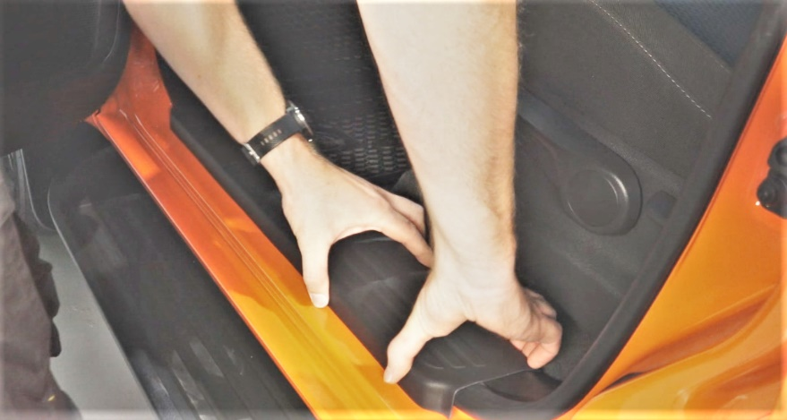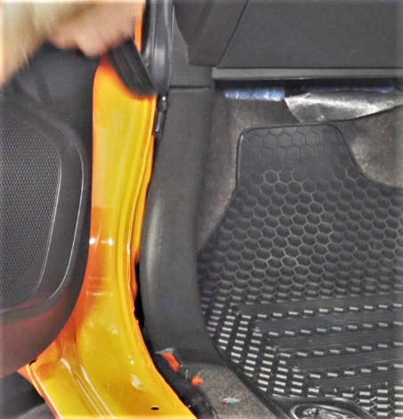

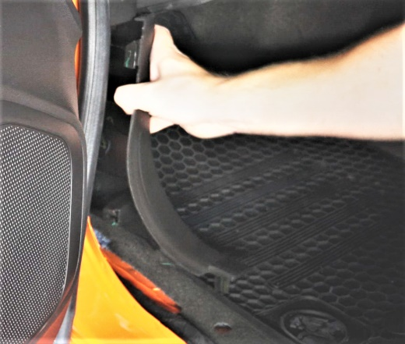

Step 8) Locate the cab entry point from the interior

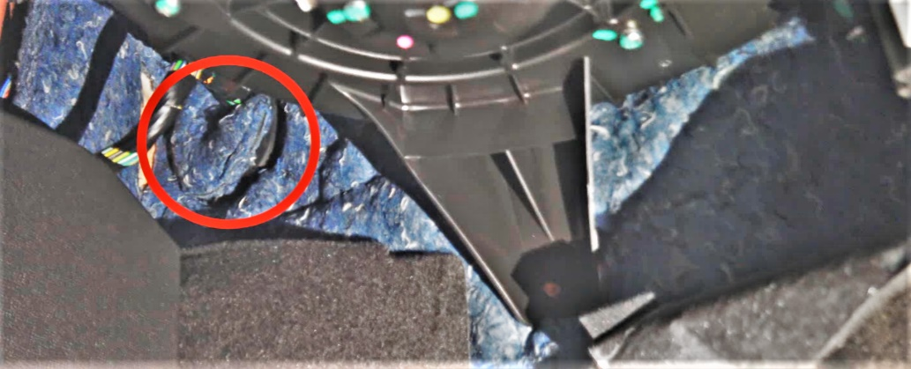

Step 9) Make a small incision in the cab entry rubber seal

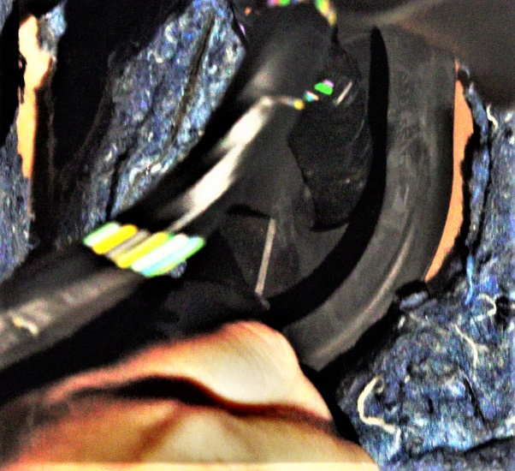
Step 10) Insert a wire through the incision

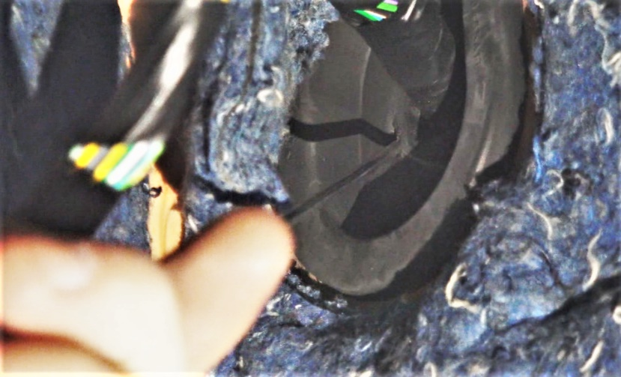

Step 11) Tape the Lock/Unlock cable to the wire and draw it back through into the cab interior

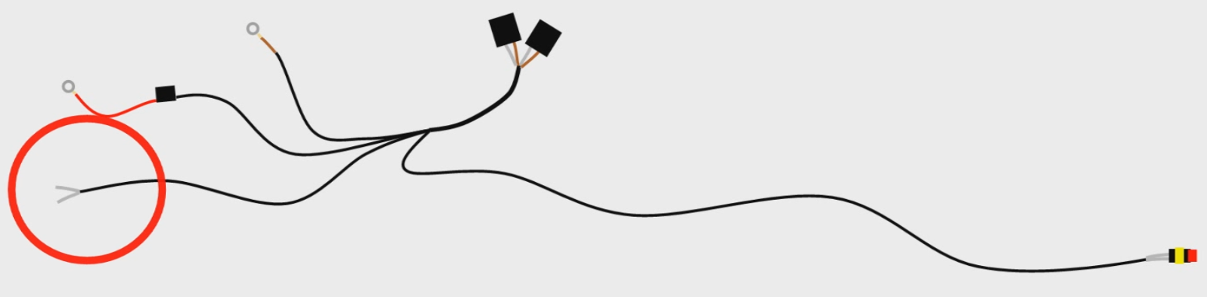

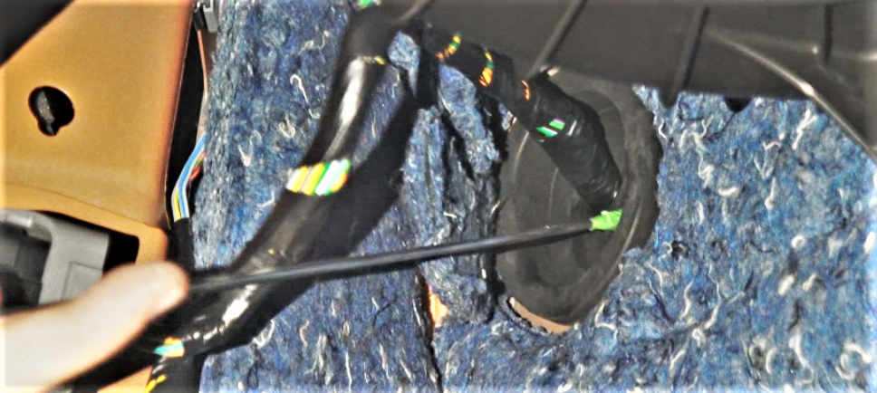

Step 12) Behind the kick panel, undo the plug to make it easier to access the wires

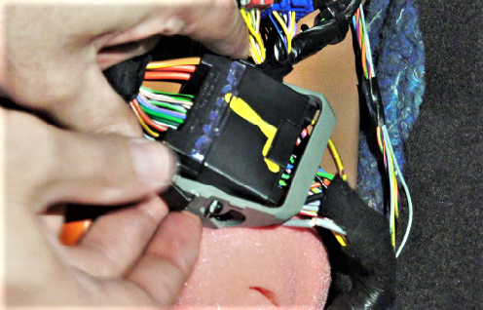

Step 13) Identify the wires with the colour blends indicated

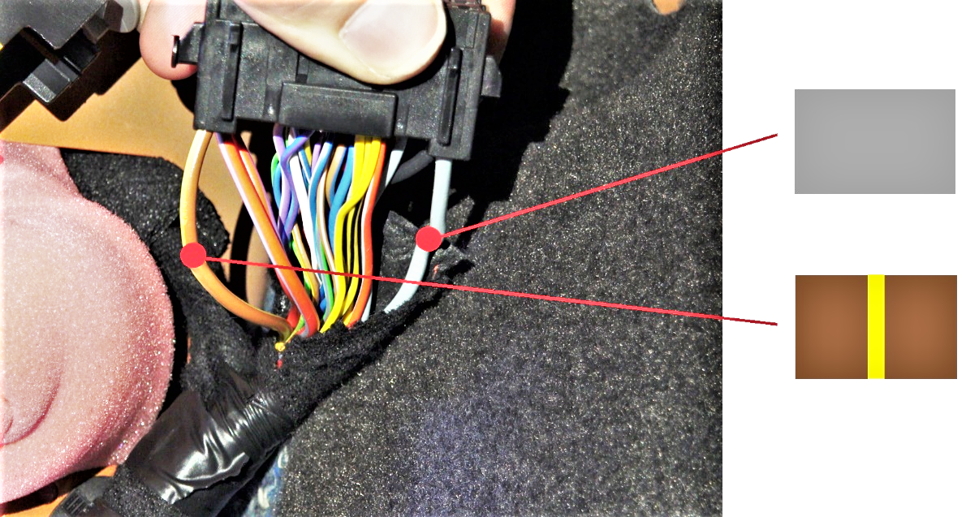

Step 14) Place one of the provided clips over the Grey wire

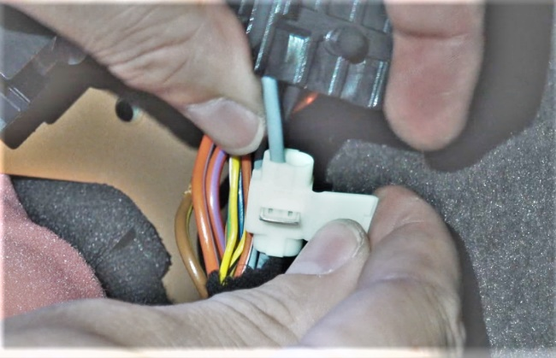

Step 15) Insert the labelled ‘Lock’ into the plastic clip alongside the Grey/Brown wire

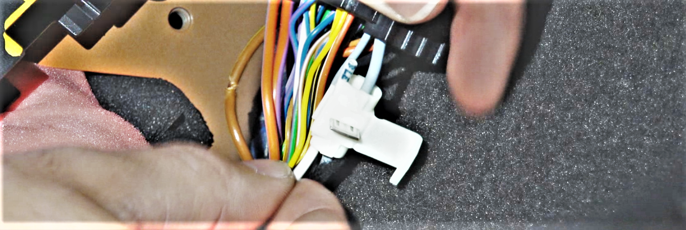

Step 16) Clamp the clip closed until the metal plate is no longer protruding, and close the clip

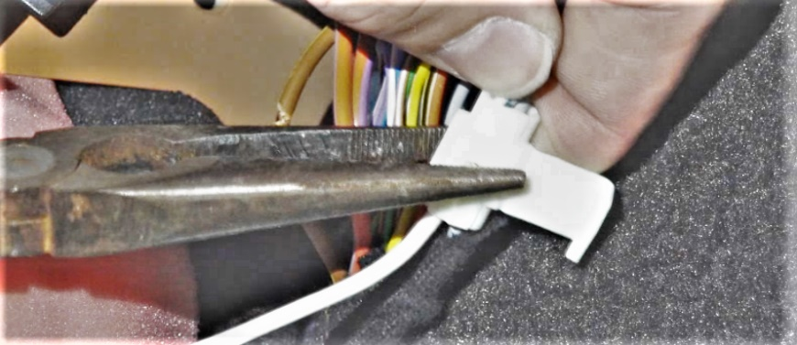

Step 17) Repeat Steps 14-16 for the Brown/Yellow wire

Step 18) Insert the plug back into its socket

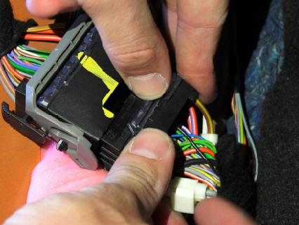

Step 19) Re-install the plastic caps & rubber seal in the passenger’s side door

Step 20) Take the last cable remaining on the loom and feed it down the firewall so it comes out underneath the vehicle

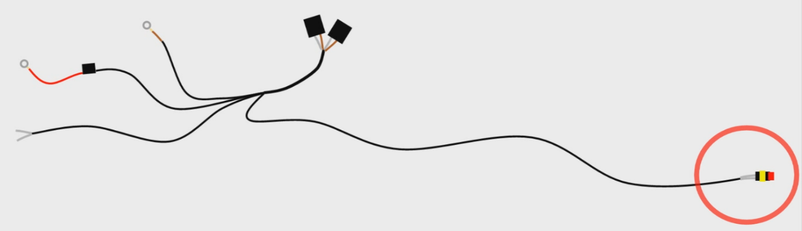
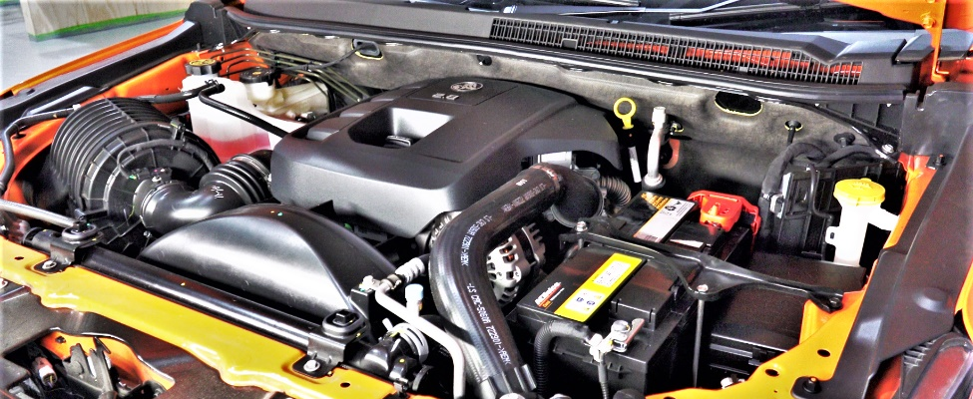

Step 21) Run down the length of the chassis and cable tie in place
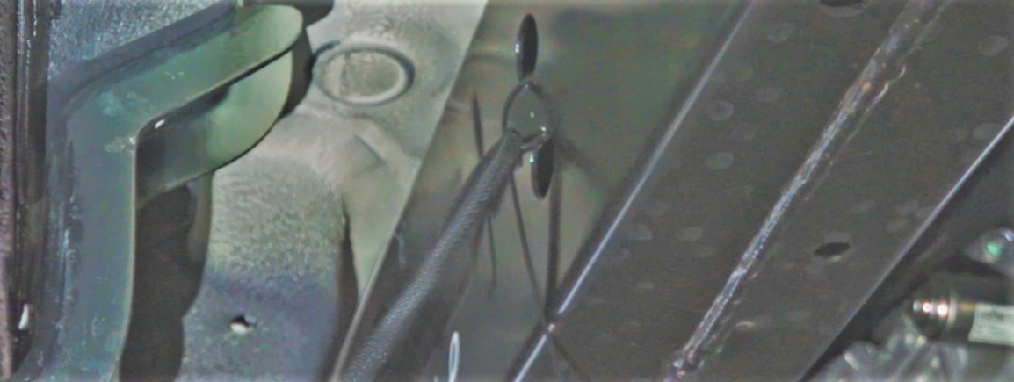

Step 22) Pull up through the gap between the cab and wellside

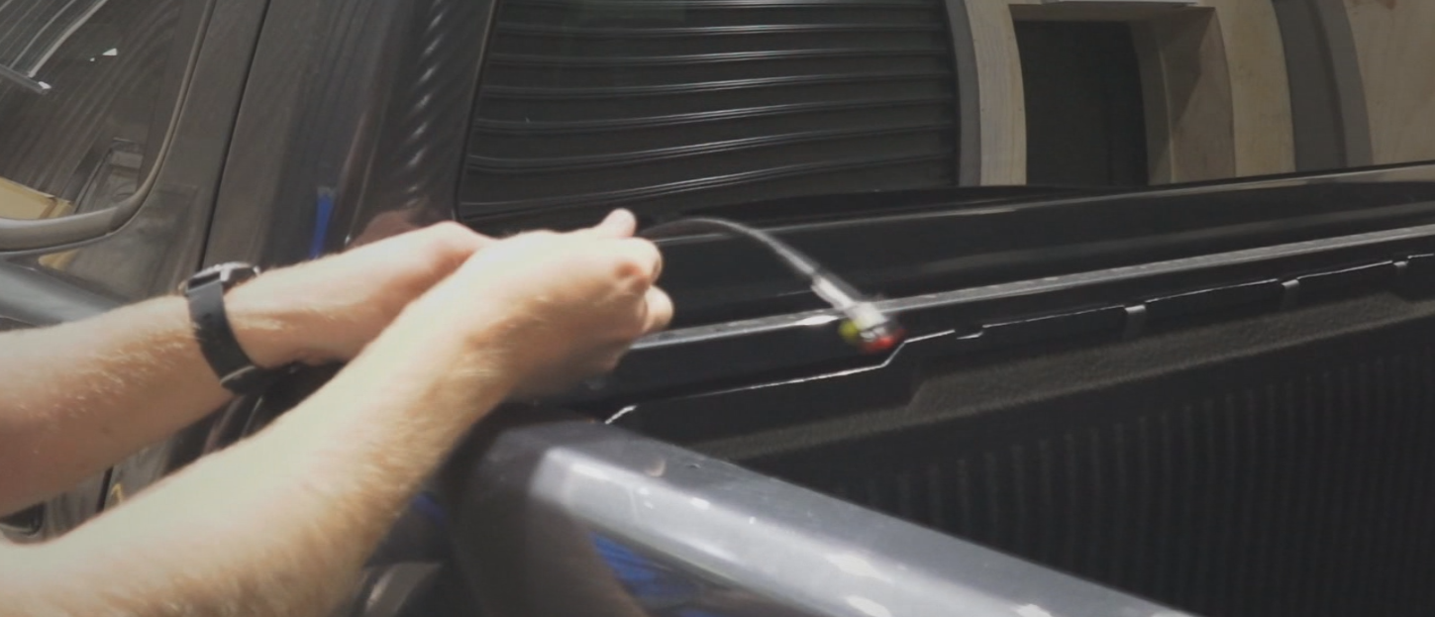

Step 23) Install the Load-Lid as per fitting instructions provided

Step 24) Connect the vehicle wiring loom to the plug already installed in the Load-Lid

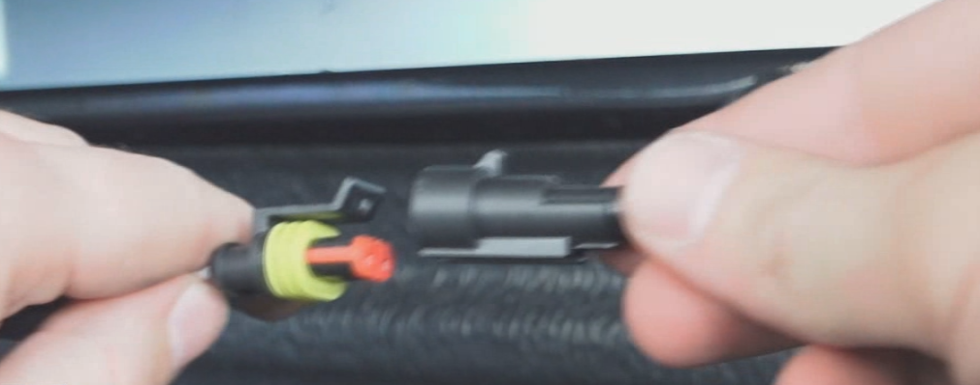

Step 25) Cable tie any slack cables safely out of sight and where they won’t hinder moving parts

Your central locking is now fully fitted and ready to use.
Thank you again for using Utemaster™ and don’t forget to keep checking our website for our latest innovations!

