Mercedes-Benz X-Class 2017-2020
Load-Lid Central Locking Fitting Instructions

Thank you for purchasing a quality Utemaster™ product, our aim is providing you with as much assistance as possible throughout the fitting process. Please call 0800 683 352 or email: sales@utemaster.co.nz if assistance is needed.

We recommend watching the installation video before attempting to install

Enter this address into your web browser to view the fitting video:
https://wi.st/33JZ47T

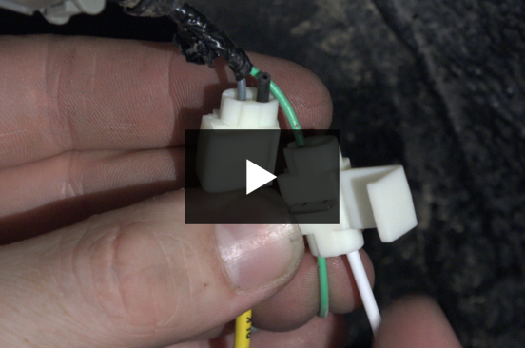

DESPATCH:

1x 80606-26 / WHUTELL-08EXT 1.0

Step 1) Under the passenger’s side rear wheel arch, remove the 4x clips indicated below and remove the plastic cover to expose the wires inside

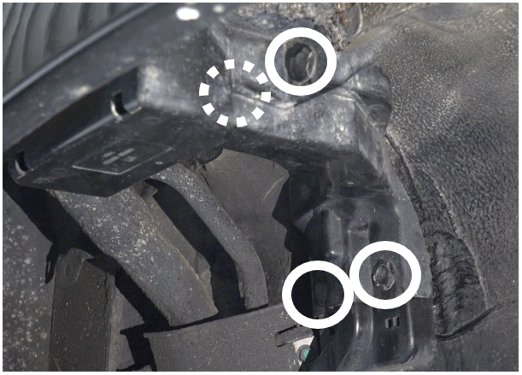

Step 2) Open up the plastic sleeve around the wiring – wires inside should be green and grey
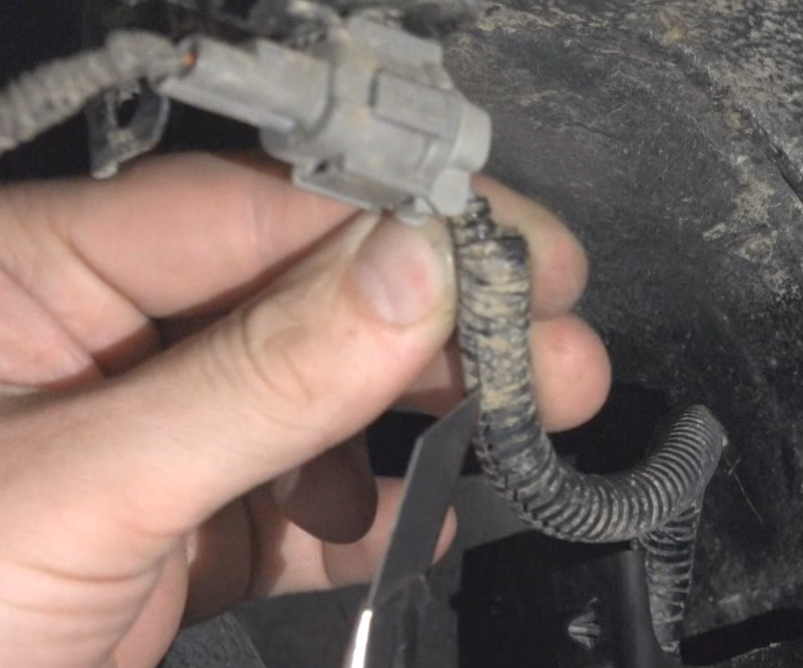

Step 3) Place one of the provided white clips over the grey wire

Step 4) Take the provided wiring loom and insert the black wire into the white clip
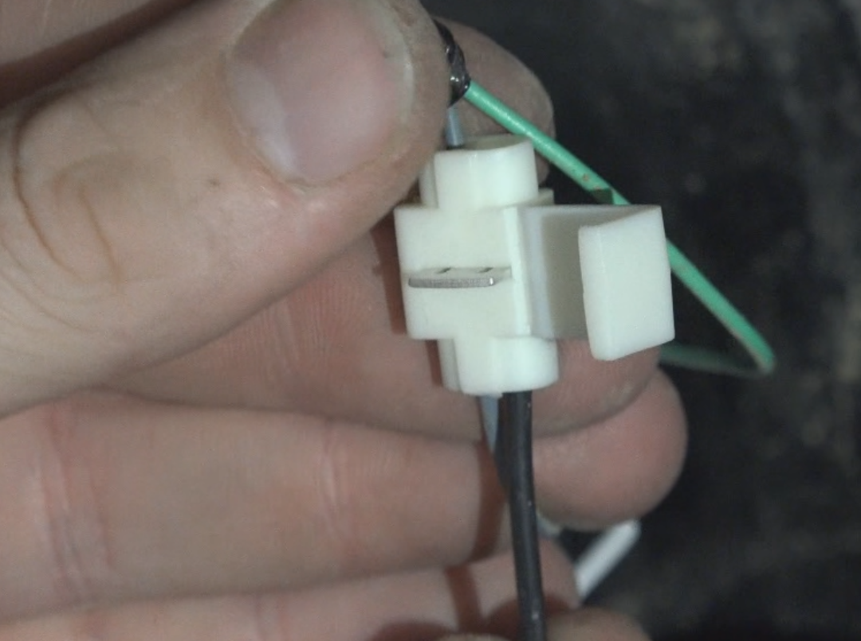

Step 5) Squeeze the metal clip with pliers until it sits completely inside the plastic clip
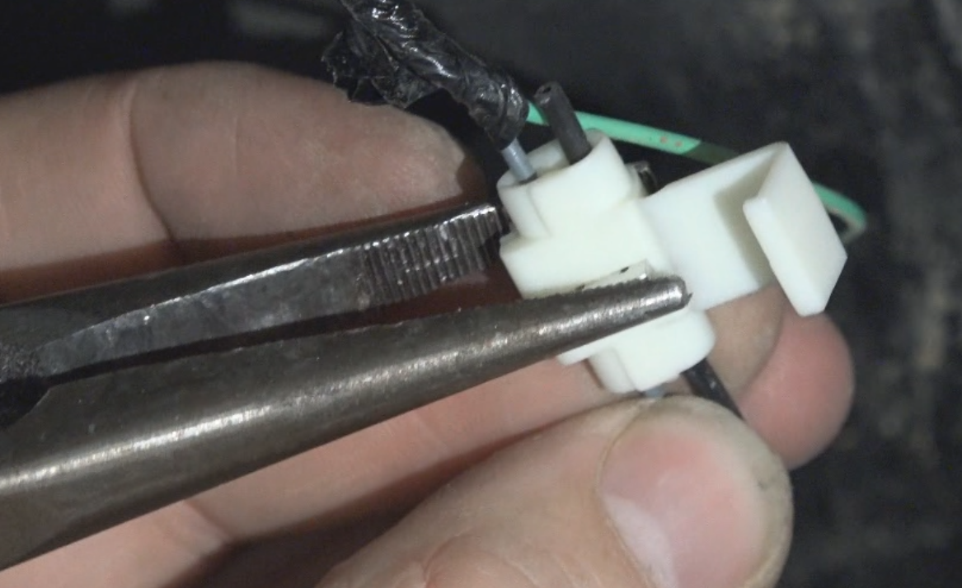
Step 6) Close the clip
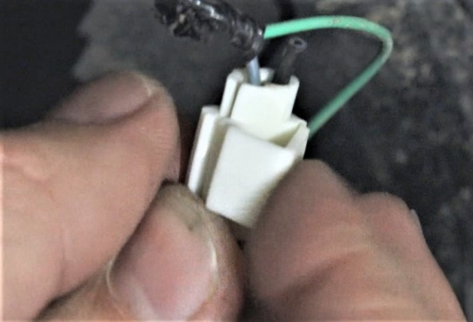

Step 7) Repeat steps 3-6 for the green wire

Black > Grey
White > Green

Step 8) Insulation tape around both clips and the wire junction
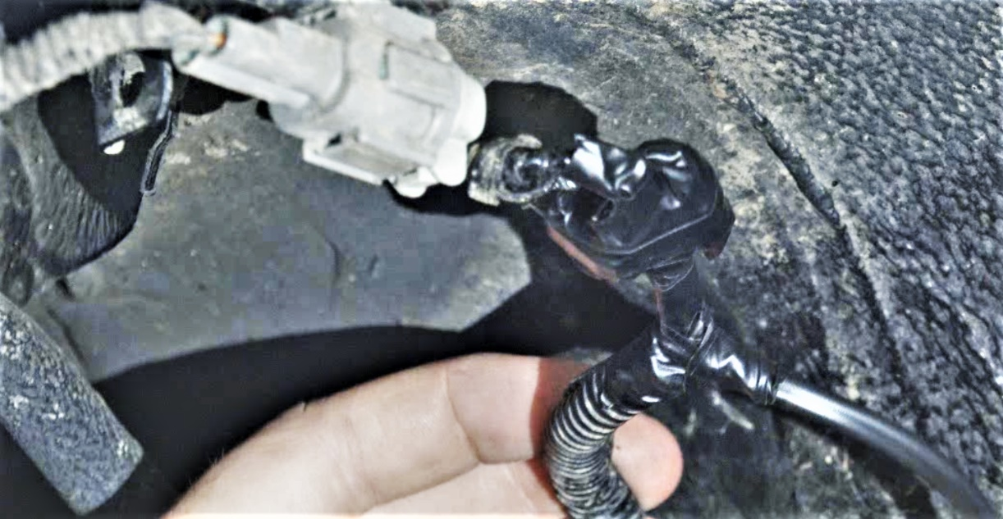

Step 9) Feed the plug end of the wiring loom over the fuel filler and up to the front corner of the wellside
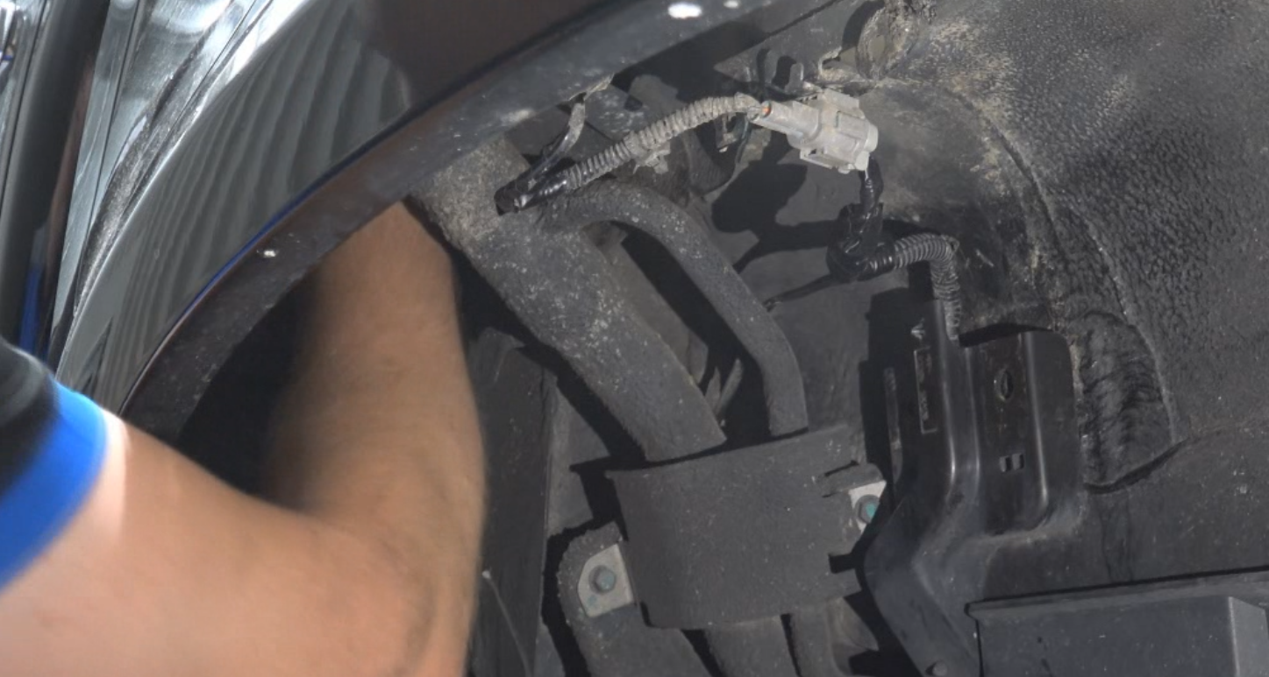
Step 10) Pull the plug through the hole in the front of the wellside and place it inside the wellside. Cable tie any slack cable remaining inside the wheel arch
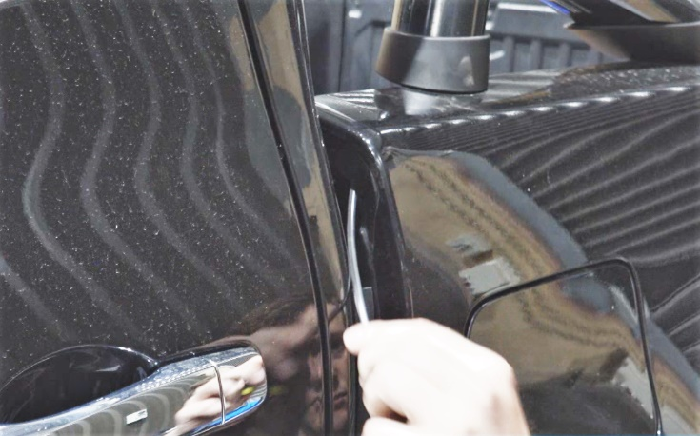

Step 11) Reinstall the plastic cap
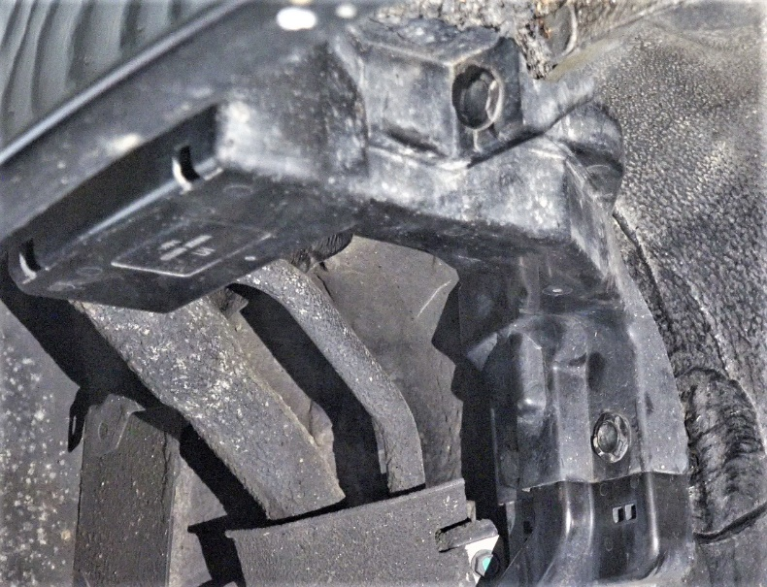

Step 12) Install the Load-Lid as per fitting instructions provided

Step 13) Connect the vehicle wiring loom to the plug already installed in the Load-Lid

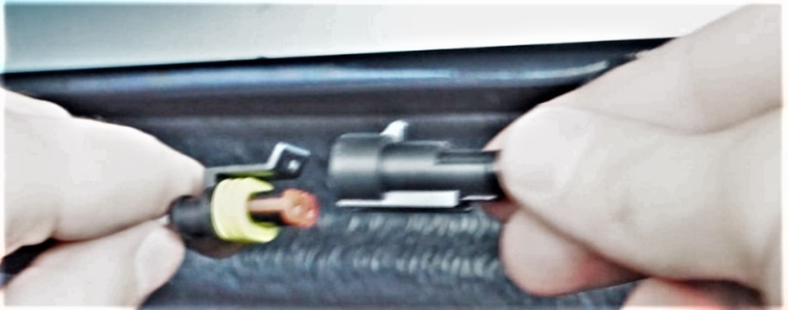

Your central locking is now fully fitted and ready to use.
Thank you again for using Utemaster™ and don’t forget to keep checking our website for our latest innovations!

